Install Jupyterlab on windows 11

1. Install Rust for windows (exe program) - <https://www.rust-lang.org/tools/install>

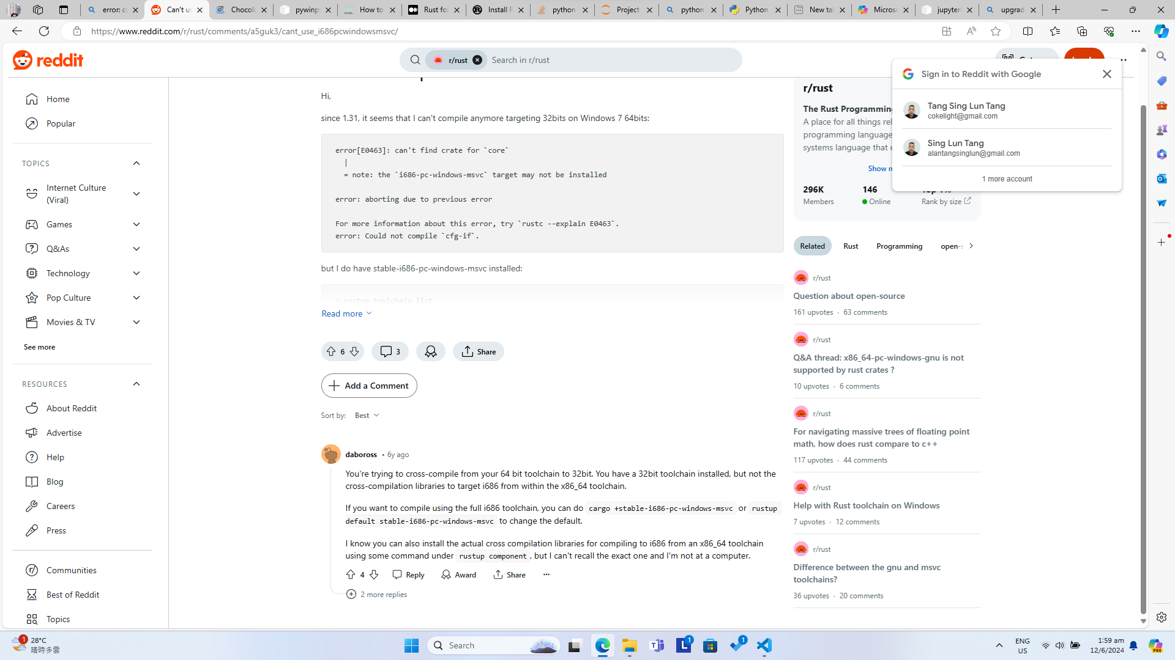

There are some errors when install jupyterlab. If you see this error:

“error: could not compile `windows_i686_msvc` (lib) due to 2 previous errors”.

Please refer the above screen shot for solution.

1. If you want to upgrade python which is installed previously from window exe file, you don’t need to uninstall it. Follow the below steps:

* Type in command: refreshenv
* Type in command: choco install --force python --version 3.7.6

If you are using windows, you need to run administrative privileges to run the command prompt. You need to install the package manager “Chocolate”. For detailed instructions how to install please visit the site: <https://chocolatey.org/install#individual>.